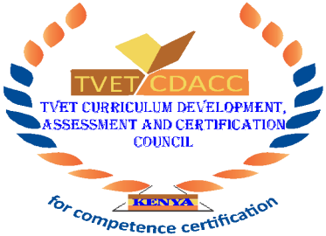

**TVET CURRICULUM DEVELOPMENT, ASSESSMENT AND CERTIFICATION COUNCIL (TVET CDACC)**

**CARPENTRY LEVEL 5**

**Qualification**  **:** Carpentry Level 5

**Unit Code** **:** CON/OS/CAJ/CR/07/5/A

**Unit of Competency :** Stairs

**WRITTEN ASSESSMENT**

**INSTRUCTIONS TO CANDIDATE**

You have **TWO HOURS** to answer all the questions.

Marks for each question are indicated in the brackets.

The paper consists of **TWO** pages

Do not write on the question paper.

A separate answer booklet will be provided.

**This paper consists of two (2) printed pages**

**Candidates should check the question paper to ascertain that all the pages are printed as indicated and that no questions are missing.**

1. a. Define a stair. **(1mks)**

b. Define the following terms.

1. Rise
2. Going
3. Flight
4. Pitch **(4mks)**

c. Describe **five** members of a timber stair

1. Riser
2. Tread
3. String
4. Nowel post
5. Balusters **(10mks)**

2. a. State different materials used in construction of stairs. **(5mks)**

b. Explain **five** functional requirements of a stair. **(10mks)**

3. a. Sketch a joint that can be used between; **(10mks)**

1. Riser and string
2. Riser and tread